SIMATS ENGINEERING (SAVEETHA SCHOOL OF ENGINEERING)
Department of Computer Science and Engineering

ASSESSMENT TOOL 1 – Coding Challenge Task

Course Code: | CSA06 | Course Title: | Design and Analysis of Algorithms
CO Assessed: | CO4: Articulation (BL4, BL5) | Assessment: | Assessment Tool 1 – Coding Challenge Task
Weightage: | 40% of CIA | Total Marks: | 100
CO4 Statement: | Solve optimization problems using dynamic programming and greedy strategies.
Student Name: | DIVYASREE.P | Reg. No.: | 192565016
Section / Batch: | 2025 | Date: | 22/08/2026
Instructions to Students
- Answer the following question. Total Marks: 100.
- Carefully analyze the given questions.
- Write clear code for the given problem.
- Analyze the Time complexity and Space complexity of your code using dynamic programming and greedy strategies

Question Type | Focus Area | Questions
Coding Challenge Task | Focus on Code and analyze optimization problems using dynamic programming and greedy strategies | Q1

SECTION A – Coding Challenge Task

Code of Conduct
I DIVYASREE.P (192565016) (Name / Reg No) certify that this submission is my original work and that I have adhered to the guidelines specified for this assessment. I understand that any violation of academic integrity rules will result in disciplinary action.
Signature of the Student:

RUBRICS FOR CALCULATION

Coding Challenge Task

Criteria | Weightage | Level 4 (Exemplary) | Level 3 (Proficient) | Level 2 (Developing) | Level 1 (Beginning)
Problem Understanding | 20% | Clearly understands problem constraints, edge cases, and  competitive requirements | Understands problem with minor gaps in constraints | Partial understanding; misses key constraints | Misinterprets problem or constraints
Algorithm | 25% | Selects optimal algorithm with best time and space complexity for competitive constraints | Uses efficient algorithm with minor scope for improvement | Uses basic/inefficient approach | No clear algorithmic approach
Code Implementation | 20% | Writes correct, efficient, and clean code that passes all  constraints | Code works with minor errors or inefficiencies | Partially correct code; fails for some cases | Code does not execute or gives incorrect results
Competitive Performance | 20% | Solves problem within time limits and  handles large inputs effectively | Solves within acceptable time with minor delays | Struggles with time limits or larger inputs | Unable to solve within time constraints
Test Case Handling | 15% | Handles all test cases including edge and hidden cases | Handles most test cases | Misses important edge cases | Fails on multiple test cases

Marks Evaluation:
Criteria | Wt. | Level 4 – Exemplary | Level 3 – Proficient | Level 2 – Developing | Level 1 – Beginning
Problem Understanding | 20%
Algorithm | 25%
Code Implementation | 20%
Competitive Performance | 20%
Test Case Handling | 15%
Total Marks (100):

Faculty In-charge | Course Coordinator | Head of Department
Name: | Name: | Name:
Signature: | Signature: | Signature:
Date: | Date: | Date:

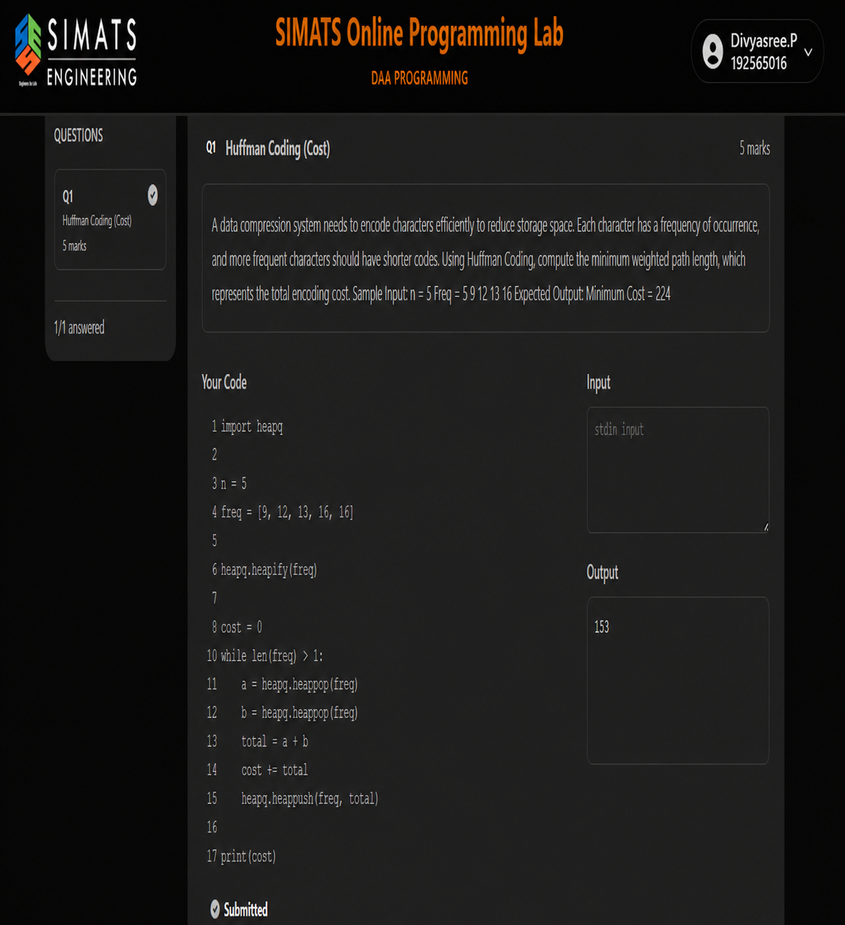

EXPERIMENT REPORT

Title: Huffman Coding (Cost)

Aim

To implement the Huffman Coding algorithm using a min-heap and calculate the minimum weighted path length or total encoding cost.

Problem Description

Huffman Coding is a data compression algorithm used to assign shorter codes to frequently occurring characters and longer codes to less frequent characters. The algorithm reduces the overall storage space required for encoding data. The minimum encoding cost is calculated by repeatedly combining the two smallest frequency values.

Algorithm

- Start the program.
- Import the heapq module.
- Store the frequency values in a list.
- Convert the list into a min-heap.
- Initialize the cost as zero.
- Remove the two smallest frequency values.
- Add these two values.
- Add their sum to the total cost.
- Insert the combined value back into the min-heap
- Repeat the process until only one element remains.
- Display the final cost.
- Stop the program.

Program
import heapq

n = 5
freq = [9, 12, 13, 16, 16]

heapq.heapify(freq)

cost = 0

while len(freq) > 1:
a = heapq.heappop(freq)
b = heapq.heappop(freq)

total = a + b
cost += total

heapq.heappush(freq, total)

print(cost)

Explanation

The program uses the Python heapq module to create a min-heap. The frequency values are stored in a list and converted into a min-heap using heapify().
The program repeatedly removes the two smallest frequency values from the heap. These values are added together, and their sum is included in the total encoding cost. The combined value is then inserted back into the heap.
This process continues until only one value remains. The final accumulated value represents the minimum weighted path length or Huffman coding cost.

Input
5
9 12 13 16 16

Output
153

Result

Thus, the Huffman Coding algorithm was successfully implemented using a min-heap, and the minimum encoding cost obtained is 153.

